## UPPAAL Simulation

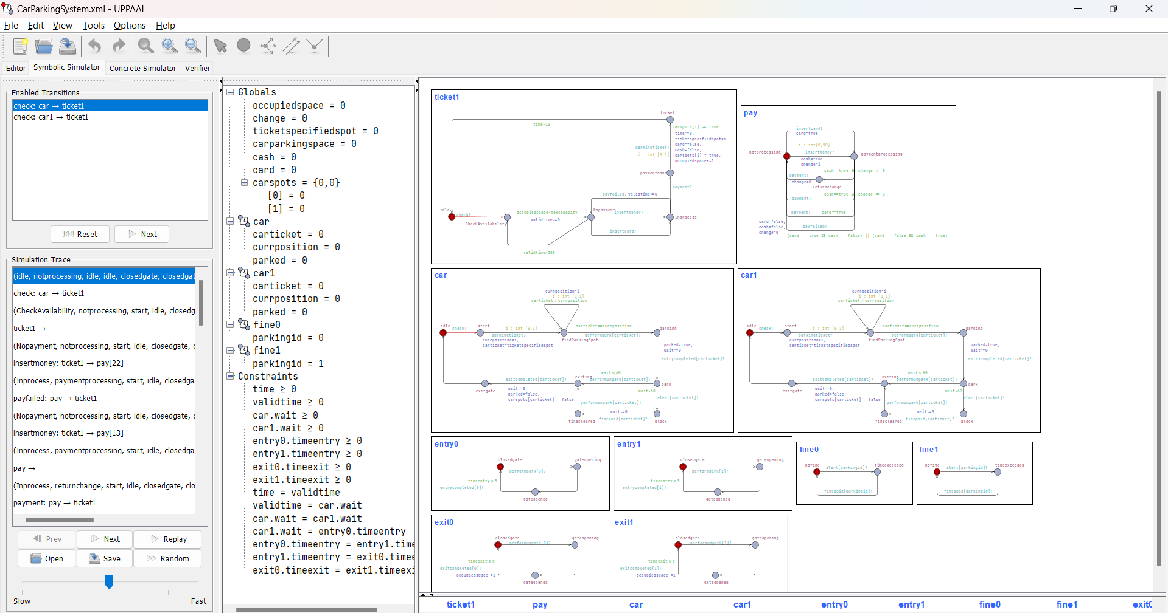

Car1 is sending signal to check for availibility.

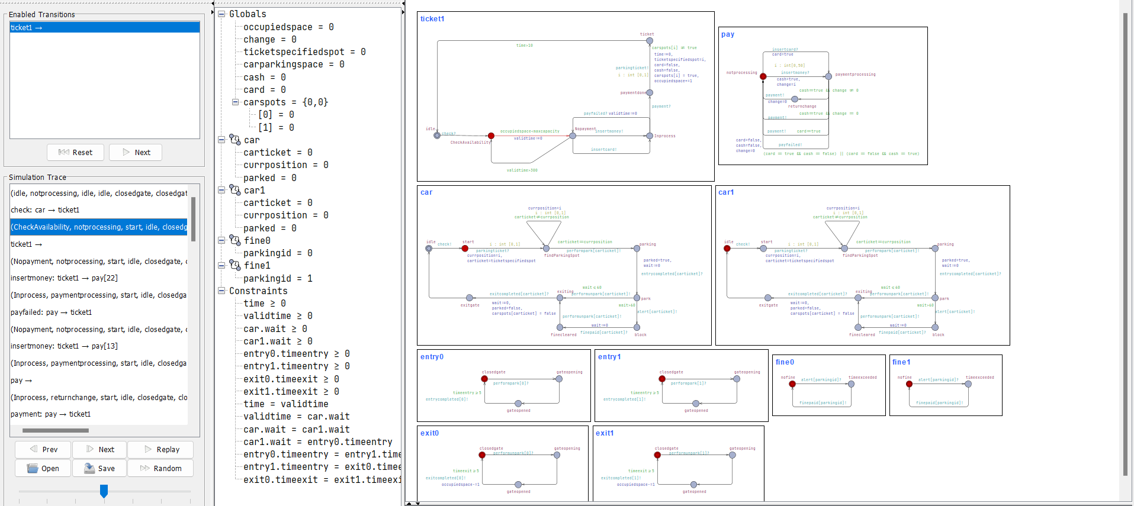

Car1 is at the gate and checking for the availability of space

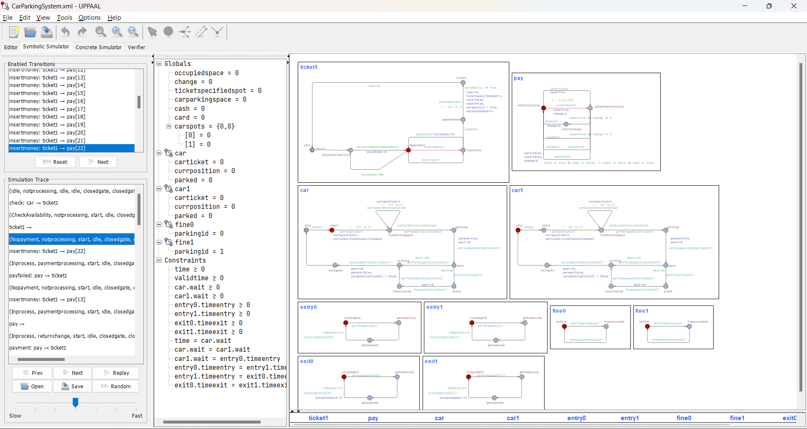

Space is available and the user moves to nopayment

User pays through cash and has rs 22 change to be returned.

Payment is failed and the user is going to retry with a different note, now change to be returned is RS 13.

User change is returned and payment is successful

Payment module has returned to noprocessing following a successful payment and ticket module is at payment stage and generating a ticket.

Car got ticket id 0 and is at the space, meanwhile another car is at the teicketing booth checking for space.

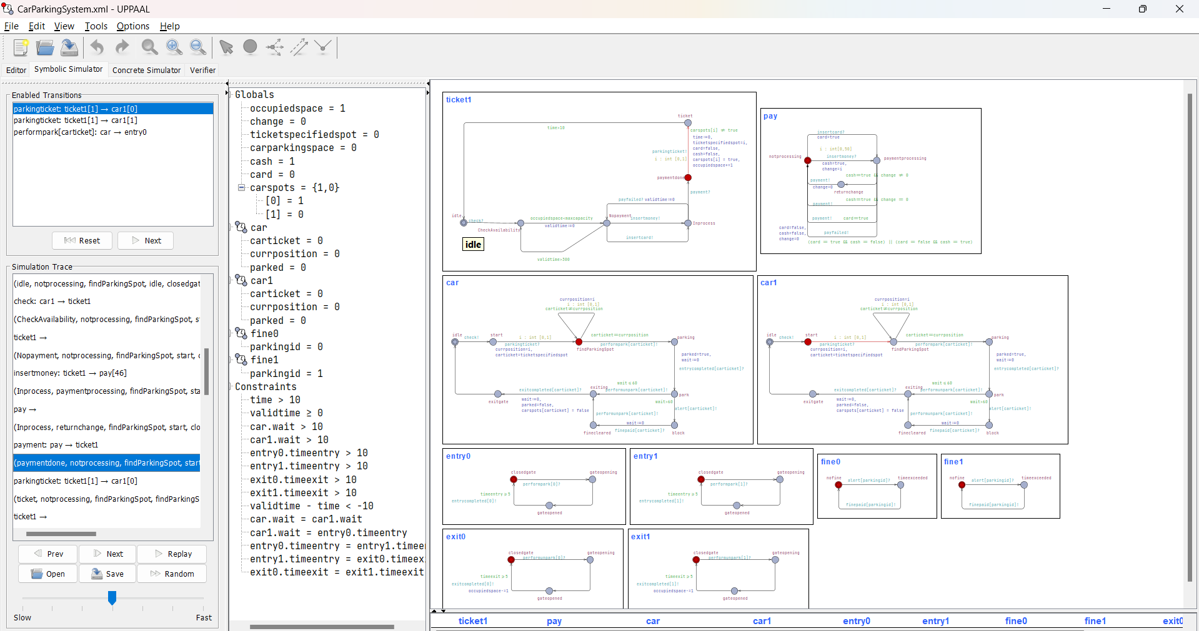

Second car pays for the ticket and gets a ticket of 1 as only that spot is available. It is currently at spot 0.

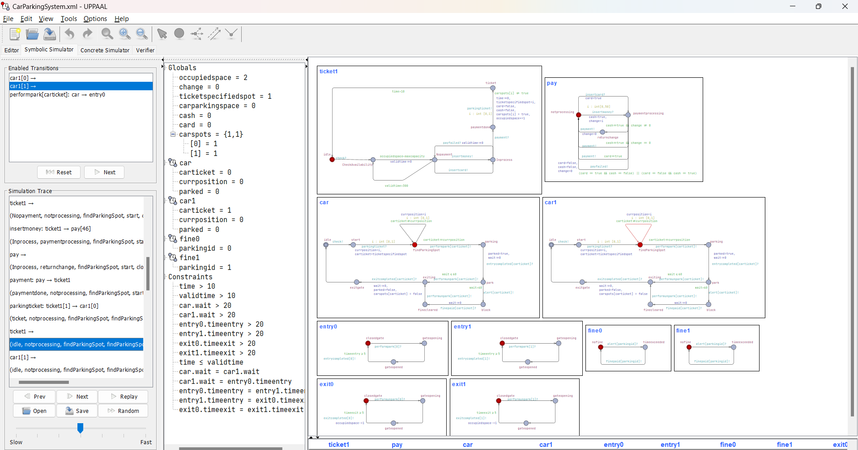

Second car tries to find the spot whereas first car is yet to start the parking process

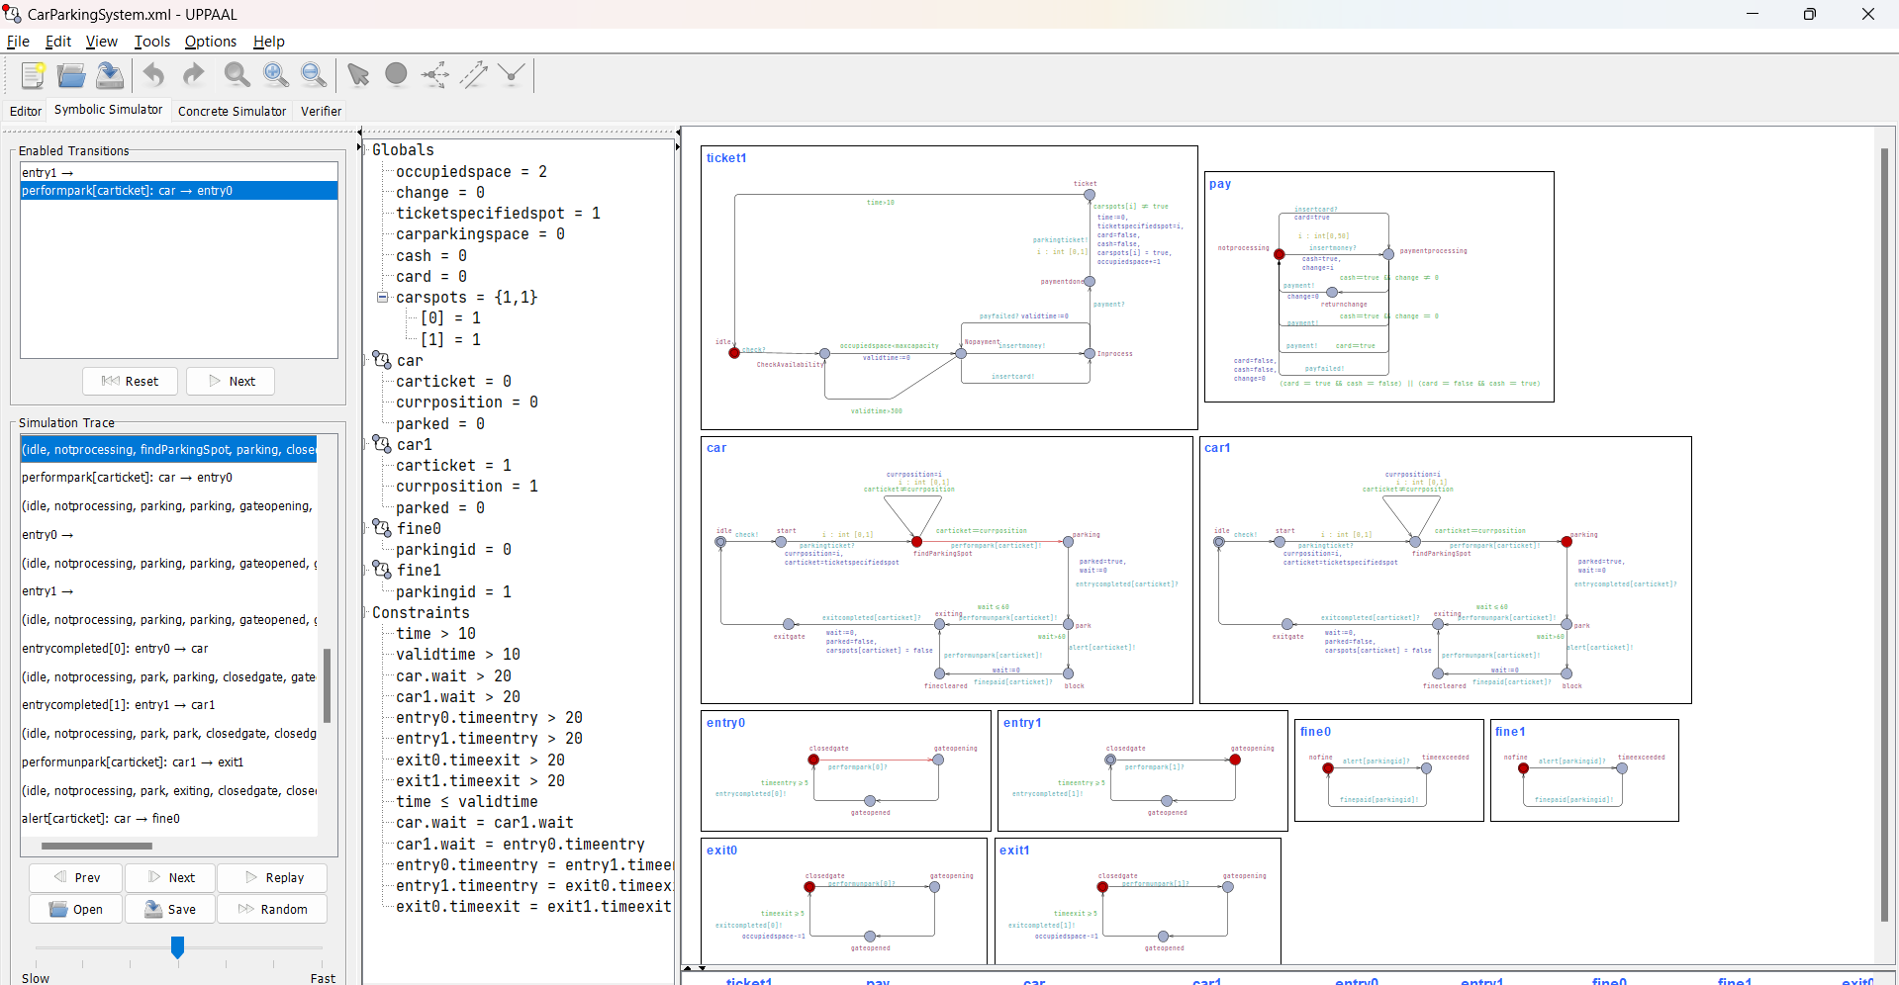

Second car ahs found the spot whereas first car is parking

Both cars have started the parking process together and the gates for both the parking spots are opening.

Both cars have parked successfully

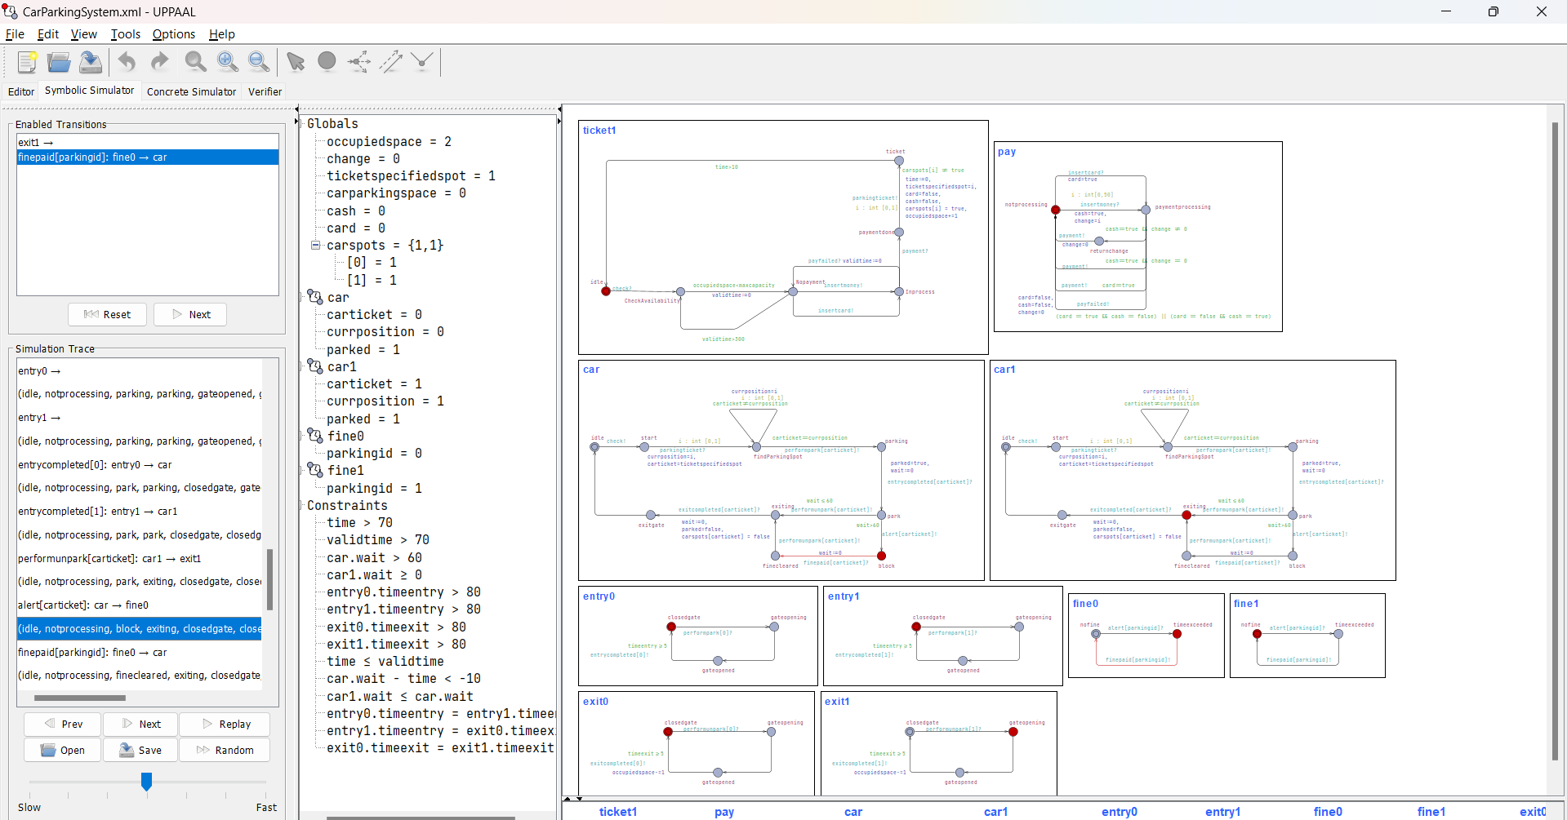

Car1 has initiated the exit process and the exit gate for that spot is openeing whereas car has overstayed and is now in block state, has to pay fine

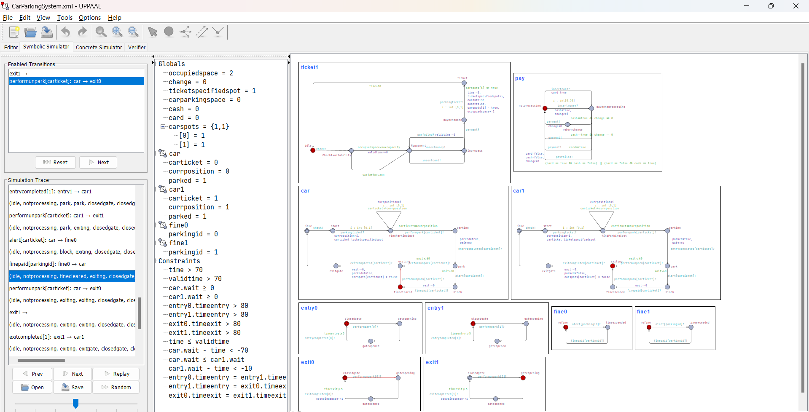

Fine has been paid whereas the other car is exiting still

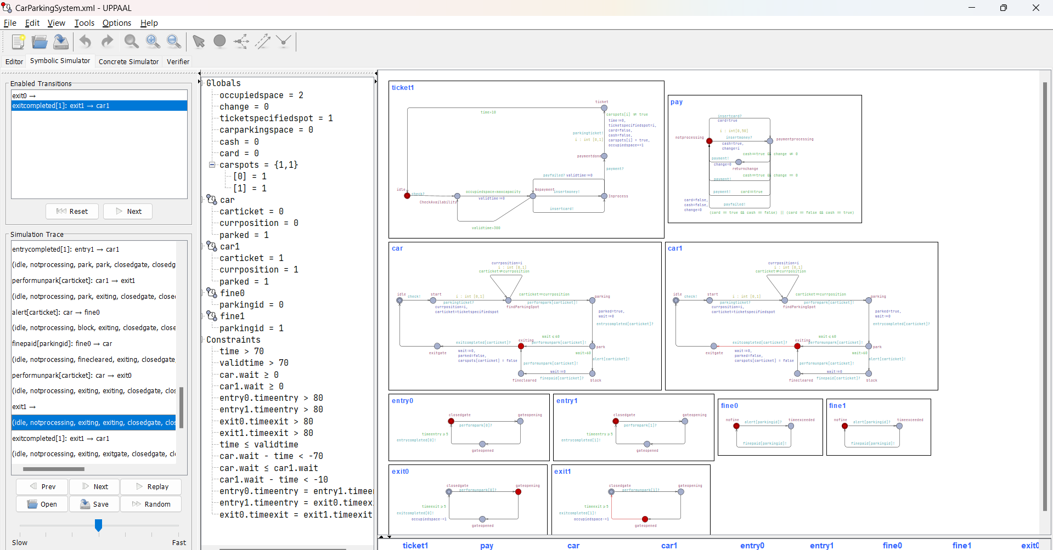

Car1 parking gate has opened, wheras car has also given the signal to exit, so its gate is also openeing

Car1 has exited and is now in idle state whereas car is exiting still.

Both cars in original state.

## Swimlanes

